CPE 301 – SPRING 2015

DESIGN ASSIGNMENT 4

|  |  |  |  |
| --- | --- | --- | --- |
| **NO** | **SUBMISSION ITEM** | **COMPLETED (Y/N)** | **MARKS**  **(/MAX)** |
| 0. | Flowchart of code | Y |  |
| 1. | AVR C Code that compiles and works | Y |  |
| 2. | Schematics | Y |  |
| 3. | Snapshot of board with connected components | Y |  |
| 4. | Snapshots of different colors | Y |  |
| 5. | Link to YouTube Video | Y |  |

**0 – Flowchart of code:**

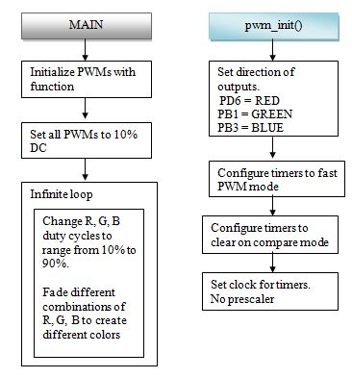

**1 - AVR C Code**

/*

Emmanuel Sanchez

CPE 301 - DA4 RGB LED changing colors using PWM

*/

#define F_CPU 16000000UL //define clock frequency

#include <avr/io.h>

#include <util/delay.h> //needed for delay

void pwm_init(); //initialize PWM channels

void setDC10(); //set R, G, B channels to 10% DC

int main(void)

{

pwm_init(); //initialize PWM channels

//set R, G, B channels to 10% DC

OCR0A = 0x19; //note: 0x19 = FF * 10%

OCR1A = 0x19; //note: 0x19 = FF * 10%

OCR2A = 0x19; //note: 0x19 = FF * 10%

while(1)

{

//note: 0xE6 = 90% DC

while(OCR0A < 0xE6){ //r fade in

OCR0A += 0xF; //increment DC

_delay_ms(50);

}

//note: 0xE6 = 90% DC

while(OCR1A < 0xE6){ //g fade in

OCR1A += 0xF; //increment DC

_delay_ms(50);

}

//note: 0xE6 = 90% DC

while(OCR2A < 0xE6){ //b fade in

OCR2A += 0xF; //increment DC

_delay_ms(50);

}

//note: 0x19 = 10% DC

while(OCR0A > 0x19){ // r fade out

OCR0A -= 0xF; //decrement DC

_delay_ms(50);

}

//note: 0x19 = 10% DC

while(OCR2A > 0x19){ // b fade out

OCR2A -= 0xF; //decrement DC

_delay_ms(50);

}

//note: 0xE6 = 90% DC

while(OCR0A < 0xE6){ // r and b fade in

OCR0A += 0xF; //increment red DC

OCR2A += 0xF; //increment blue DC

_delay_ms(50);

}

//note: 0x19 = 10% DC

while(OCR1A > 0x19){ //g fade out

OCR1A -= 0xF; //decrement DC

_delay_ms(50);

}

//note: 0x19 = 10% DC

while(OCR0A > 0x19){ // r fade out

OCR0A -= 0xF; //decrement DC

_delay_ms(50);

}

//note: 0x19 = 10% DC

while(OCR2A > 0x19){ // b fade out

OCR2A -= 0xF; //decrement DC

_delay_ms(50);

}

}

}

//initialize PWMs

void pwm_init(){

//3 PWM channel outputs

DDRD |= (1<<PD6); //R OC0A

DDRB |= (1<<PB1); //G 0C1A

DDRB |= (1<<PB3); //B 0C2A

//fast pwm mode

TCCR0A |= (1<<WGM01) | (1<<WGM00); //timer 0

TCCR2A |= (1<<WGM21) | (1<<WGM20); //timer 2

TCCR1A |= (1<<WGM10); //timer 1

TCCR1B |= (1<<WGM12); //timer 1

//clear mode

TCCR0A |= (1<<COM0A1); //timer 0

TCCR1A |= (1<<COM1A1); //timer 1

TCCR2A |= (1<<COM2A1); //timer 2

//set clock, no prescaler

TCCR0B |= (1<<CS00); //timer 0

TCCR1B |= (1<<CS10); //timer 1

TCCR2B |= (1<<CS20); //timer 2

}

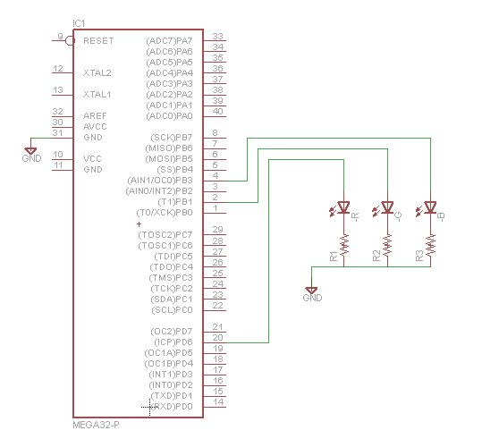**2 - Schematics**

**3 – Snapshot of board with connected components:**

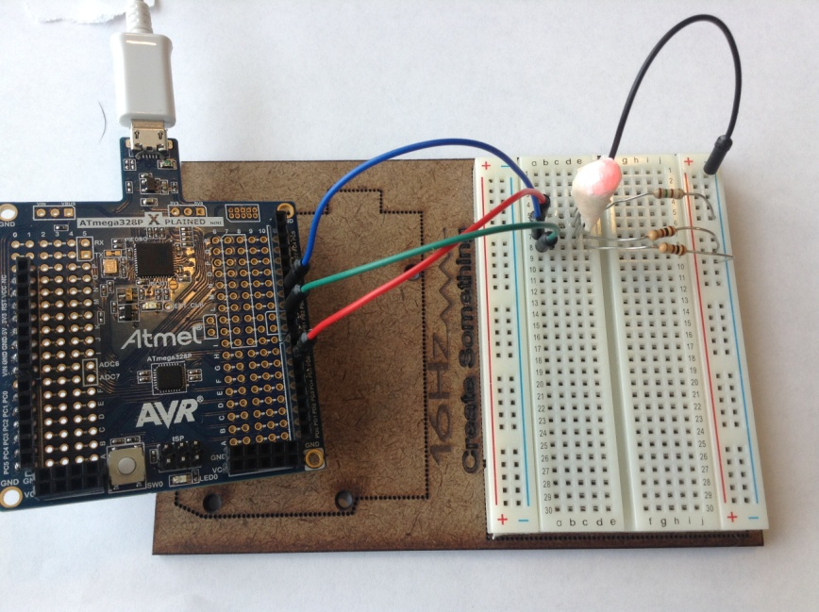

Note: I covered the RGB LED with white plastic to dim it.

**4 – Snapshots of different colors:**

These are a few of the colors. Please see video for full sequence.

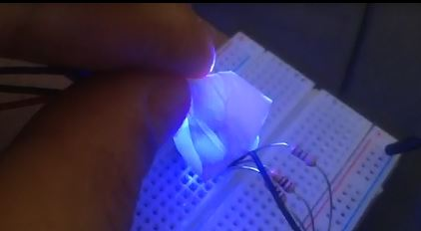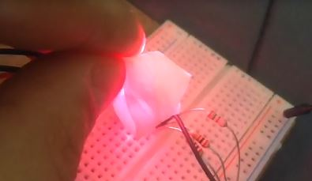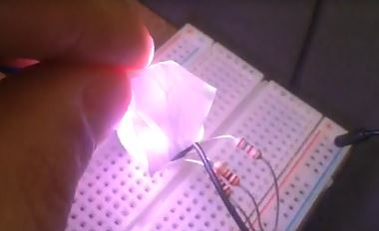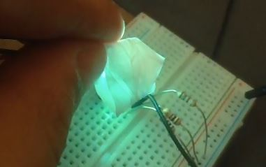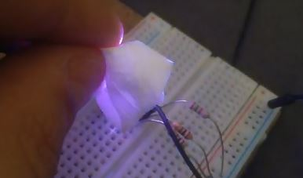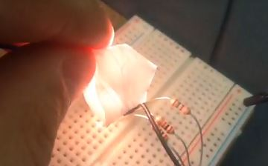

**5 - Link to YouTube Video:**

<https://www.youtube.com/watch?v=8QXxJm-F04I>

**Student Academic Misconduct Policy**

<http://studentconduct.unlv.edu/misconduct/policy.html>

“This assignment submission is my own, original work”.

Emmanuel Sanchez